

**Assignment 3**

| Karan Ashok |

MGS616 - Predictive Analytics

**Q - Identify the factors affecting the sales in Store B and extent to which these factors affect sales.**

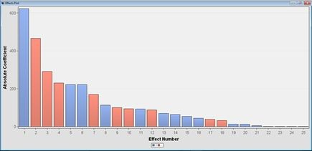

From this effect plot, we can get the inferences that for Store B, total sales is –

1. Negatively affected by year 2011. (We can infer that maybe less number of Japanese tourists came in 2011, or there was anything lacking in the Store B for that year).

2. Sales is also negatively affected by month 2 and 3. ( We can infer that less customers come in these 2 months)

3. Sales is positively affected by month 10 and 11. (We can infer that more customers come due to festival season, or some changes at the store)

4. Apart from the effect of particular year and month on the sales, we can deduce further that sales is positively affected on Sunday and negatively affected on Tuesday.

|  |  |  |
| --- | --- | --- |
| **Factors affecting Sales** | **Value of Factor** | **Estimate** |
| DB_SQ_YEN (Double Square YenWon Ratio) |  | 0.0169 |
| FLR_JPN_TOU (Floor applied on Japanese tourist) |  | 0.0748 |
| Month | 1 | -170.2 |
| Month | 2 | -291.3 |

|  |  |  |
| --- | --- | --- |
| Month | 3 | -230.6 |
| Month | 4 | -88.0168 |
| Month | 5 | 92.6789 |
| Month | 6 | -100.3 |
| Month | 7 | 113.7 |
| Month | 8 | 53.9561 |
| Month | 9 | -93.8421 |
| Month | 10 | 221.4 |
| Month | 11 | 221.4 |
| REP_Discount |  | -0.00019 |
| Weekday | Friday | 63.4712 |
| Weekday | Monday | 12.4199 |
| Weekday | Saturday | 12.2745 |
| Weekday | Sunday | 70.3254 |
| Weekday | Thursday | -32.714 |
| Weekday | Tuesday | -37.9089 |
| Year | 2011 | -466.8 |
| Year | 2012 | 44.9156 |
| of_Customers |  | 5.9472 |
| of_Items |  | 0.8446 |

**Q - Find the similarities and dissimilarities of these impact factors across the five stores**

|  |  |  |  |  |  |
| --- | --- | --- | --- | --- | --- |
| Factors | Store B | Store A | Store C | Store D | Store E |
| Year_2011 | -466.8 | -386.7 | 73.0551 | -363.4 | -304.3 |
| Month_2 | -291.3 | -428.7 | -71.3721 | -273.2 | -207.5 |
| Month_3 | -230.6 | -289.4 | -79.3976 | -195.9 | -52.8385 |
| Month_10 | 221.4 | -2.5472 | 78.1248 | 95.7403 | 163.5 |
| Month_11 | 221.4 | 202.1 | 88.0629 | 292.2 | 188.5 |
| Sunday | 70.3254 | 128.9 | - | -13.1710 | - |
| Tuesday | -37.9089 | -188.3 | - | -69.9844 | - |

**Q - Does roughly 95% of their sales come from Japanese tourists?**

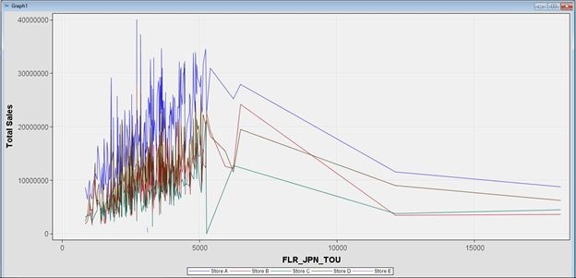

If we check out the graph between Japanese tourists and total sales grouped by stores, then there is no such correlation. Sales is varying much against the Japanese tourists.

**Q - Find the correlation between the number of Japanese tourists and the variables included in the dataset.**

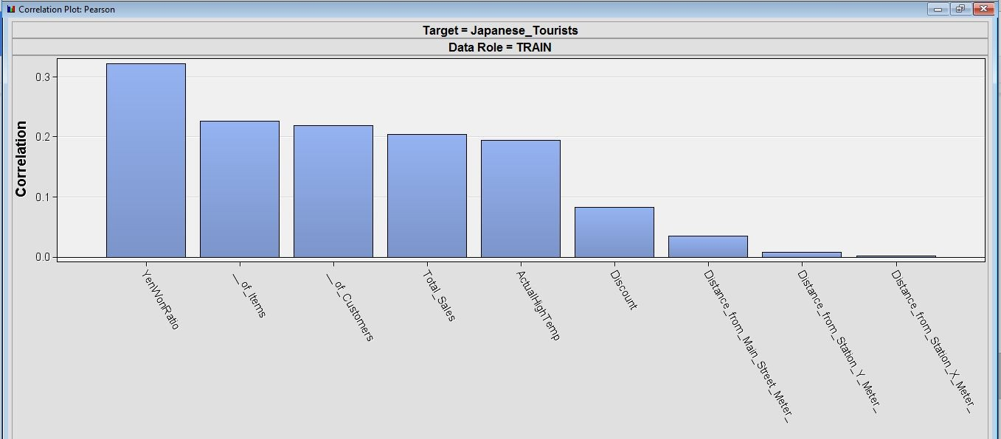

The most dominant factors which result in increase in Japanese tourists are

Yen/Won Ratio, # of customers and # of items.

**Q - Does the number of Japanese tourists may have a larger bearing on Store A’s revenues than on Store B’s?**

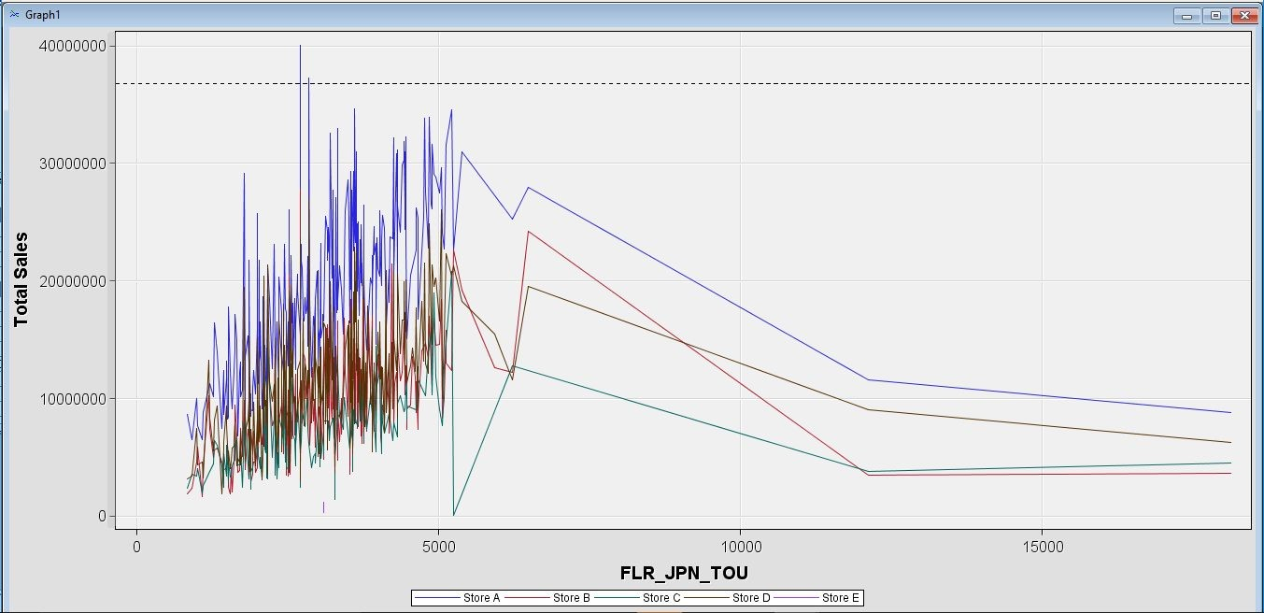

Yes. From the above graph, we can conclude that the Japanese tourists have a larger bearing on Store A.

**Q - Are tourists more likely to visit during Japanese national holidays?**

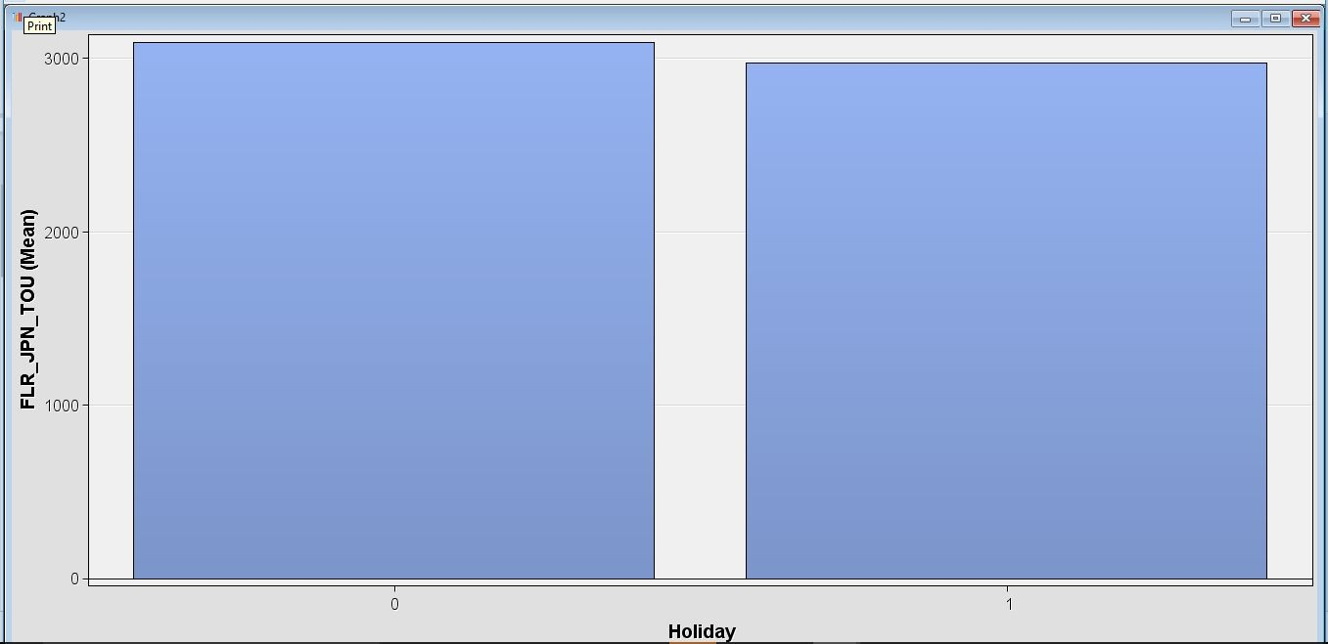

No. We don’t see any comparable difference between the number of tourists which visit on holidays and which don’t.

**Q - Does the weather may also play a role in the shopping behavior?**

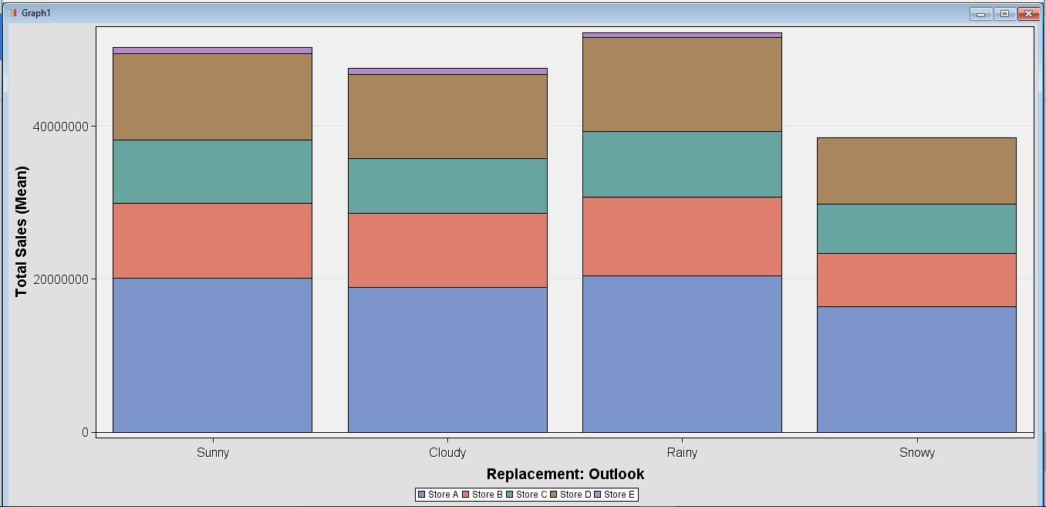

There is not much difference in the sales pattern based on weather. There is a marginal uptick in the sales for rainy weather. Only notable difference that can be deduced from the above figure is that there are almost zero sales for Store E in the snowy weather.

**Q - Mr. Choe would like to know more about the factors that affect sales in each store and the importance of such factors.**

|  |  |  |  |  |
| --- | --- | --- | --- | --- |
| **Store A** | **Store B** | **Store C** | **Store D** | **Store E** |
| 2nd Month  (Negative) | Year 2011 (Negative) | Month 11 (Positive) | Year 2011 (Negative) | Year 2011 (Negative) |
| Year 2011 (Negative) | 2nd Month  (negative) | 3rd Month  (Negative) | 11th Month  (Positive) | 1st Month  (Negative) |
| 3rd Month  (negative) | 3rd Month  (Negative) | 10th Month  (Positive) | 2nd Month  (negative) | 2nd Month  (Negative) |
| 8th Month  (Positive) | 10th Month  (Positive) | Year 2011 (Positive) | 3rd Month  (Negative) | 11th Month  (Positive) |
| 7th Month  (Positive) | 11th Month  (Positive) | 2nd Month  (Negative) | 1st Month  (Negative) | 10th Month  (Positive) |
| 11th Month  (Positive) | 1st month  (Negative) | Year 2012 (Positive) | 6th Month  (Negative) | 4th Month  (Negative) |
| Tuesday  (Negative) | 7th Month  (Positive) | 9th Month  (Positive) | 7th Month  (Positive) | 3rd Month  (Negative) |
| 6th Month  (Negative) | 6th Month  (Negative) | # of Customers (Positive) | 9th Month  (Negative) | No Holiday  (negative) |
| Saturday  (Positive) | 9th Month  (negative) | 1st Month  (Negative) | 10th Month  (Positive) | 8th Month  (Positive) |
| Sunday  (Positive) | 5th Month  (Positive) | # of Items  (Positive) | Outlook SNOWY (Negative) | 9th Month  (Positive) |

For each store, the factors which are affecting the sales are listed in descending order of their magnitude in each column.